# WELCOME

Ms.

Ayaka

MAEMURA

Flight Arrival Date: 06 Apr 2019 Flight Arrival Time: 09:30 Flight Number: QF26

Homestay Address: Angela YAKOUMELOS , 8/11-17 Burleigh Street, Burwood, NSW, 2134

Telephone: 0412 435 650 Mobile: 0412 435 650

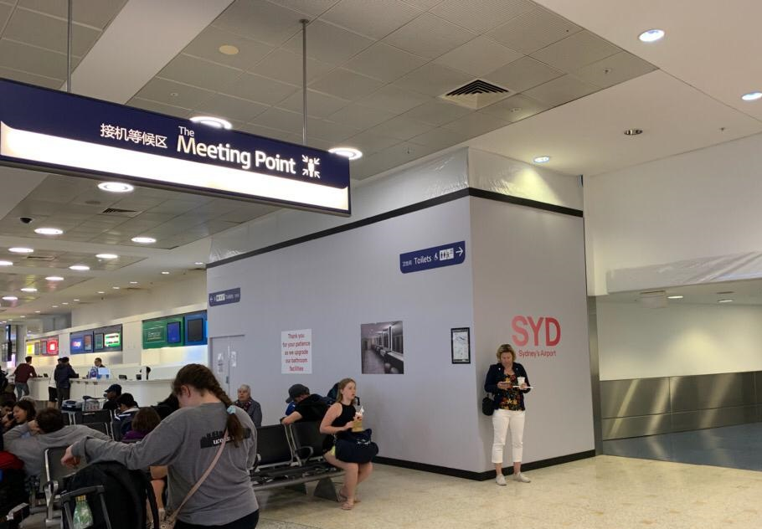

If you arrive at the International Airport:

Once you come out of the

Customs area, please go to

the ‘Meeting Point’

between Exit A and Exit B,

inside the terminal

and your driver will meet you there

If you arrive at the Domestic Airport:

Please wait for your driver at the 'luggage area' as your driver will meet you there

In case of Emergency please contact:

Castle Tour: (+61) 414 288 088 or (+61) 414 388 088

Global experience emergency number: (+61) 430 008 448

Email: [change@globalexperience.com.au](mailto:change@globalexperience.com.au)

PLEASE DO NOT LEAVE THE AIRPORT, WAIT FOR YOUR DRIVER